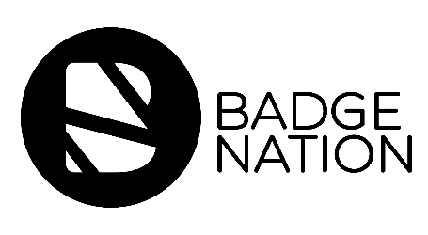

Who: Badge Earner
When: At the same time that the badge is issued
How: Email from Learning Provider
Why: To show them how they can claim their badge

Subject line: Your New Digital Badge!
From: Learning Provider email

Congratulations - you have been issued with the [insert badge name here], which recognises the skills that you have learned during [insert learning activity here]!

Digital badges are the future of recognising skills and can help you to explain your strengths, share your achievements and stand out from the crowd.

You will have received an email from Navigatr.app, the UK-based badge platform which we used to issue your badge. Sometimes this email can end up in your junk folder, so be sure to check there if it hasn’t landed in your inbox.

If you are new to Navigatr, the email will prompt you to set up an account on the platform to accept your new badge - help with setting up an account can be found on the Navigatr help centre, or by watching the ‘Creating a new user account’ chapter of this video.

