You earned it!
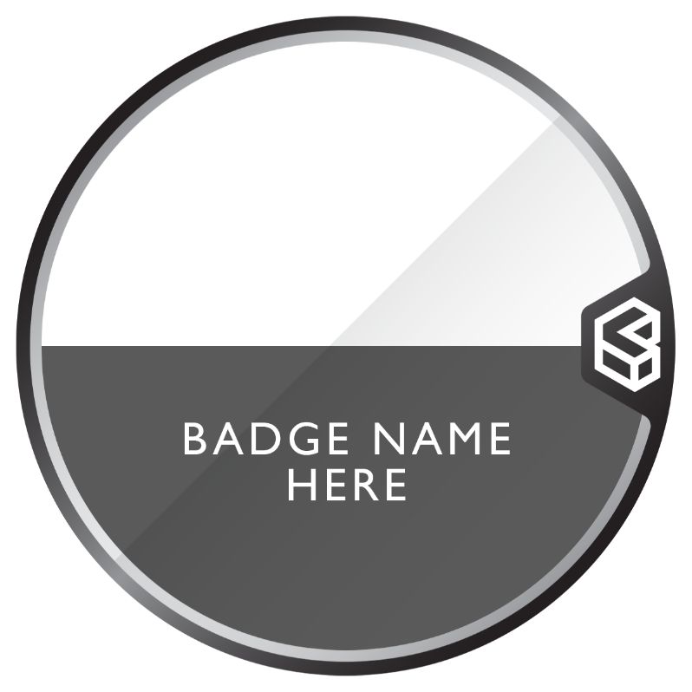
[Enter badge name here]
Get your free digital badge!
1. Scan below
2. Use claim code [enter claim code here]

Show off skills✅

[Enter QR code here]
Add to CV✅
Share on socials✅
Store in wallet ✅
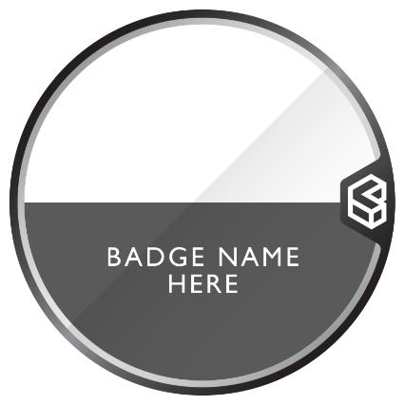
[Enter badge long title here]

[Enter badge description here]
[Enter list of tags here]
- Earning criteria
- Earning criteria
- Earning criteria
- Earning criteria
- Earning criteria
- Earning criteria
- Earning criteria
- Earning criteria
[Enter Badge Standard information here.]
[If applicable to your badge, also enter additional standards / alignments here.]

