You earned it!
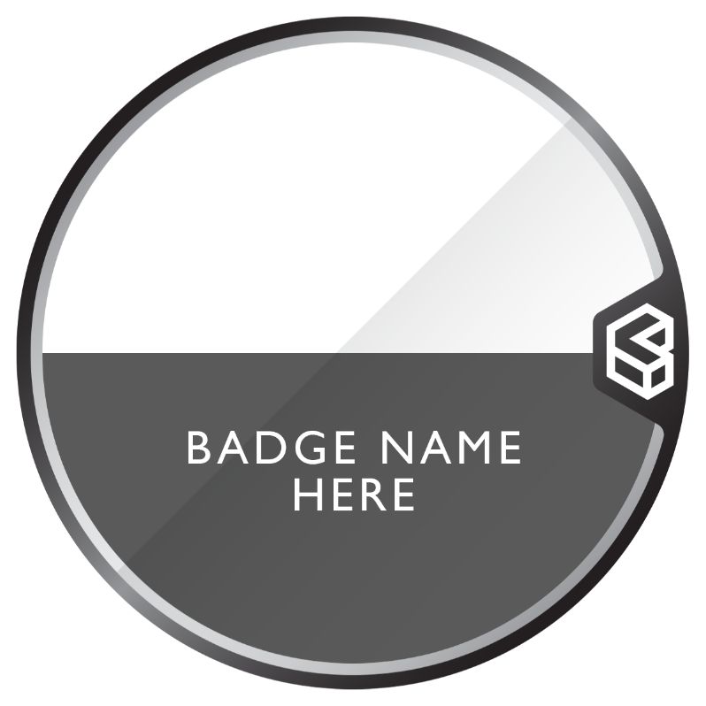
[Enter badge name here]
Get your free digital badge!
1. Scan below
2. Use claim code [enter code here]

Show off skills✅

[Enter QR code here]
Add to CV✅
Share on socials✅
Store in wallet ✅

